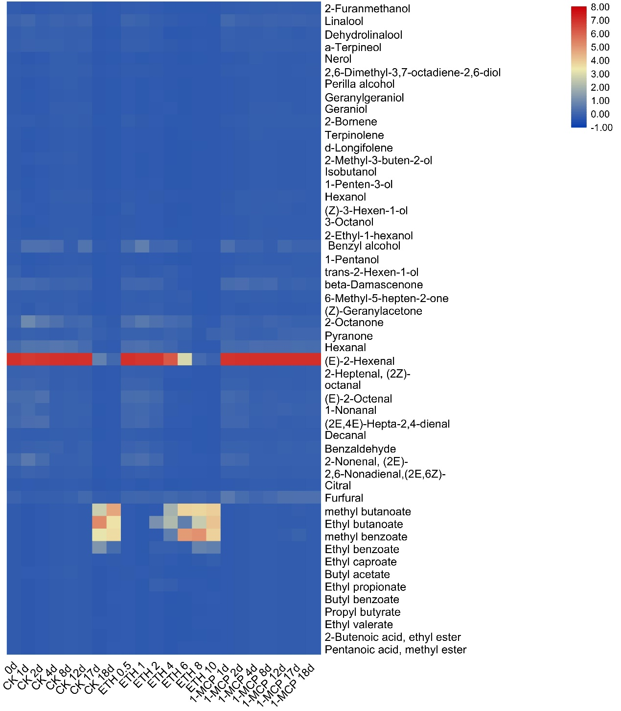
Additional file 2 Fig. S1 An heatmap of volatile compounds detected in ‘Hayward’ kiwifruit in response to ethylene (100 µl l⁻¹, 24 h) or 1-MCP (1 µl l⁻¹, 24 h) treatment during storage.
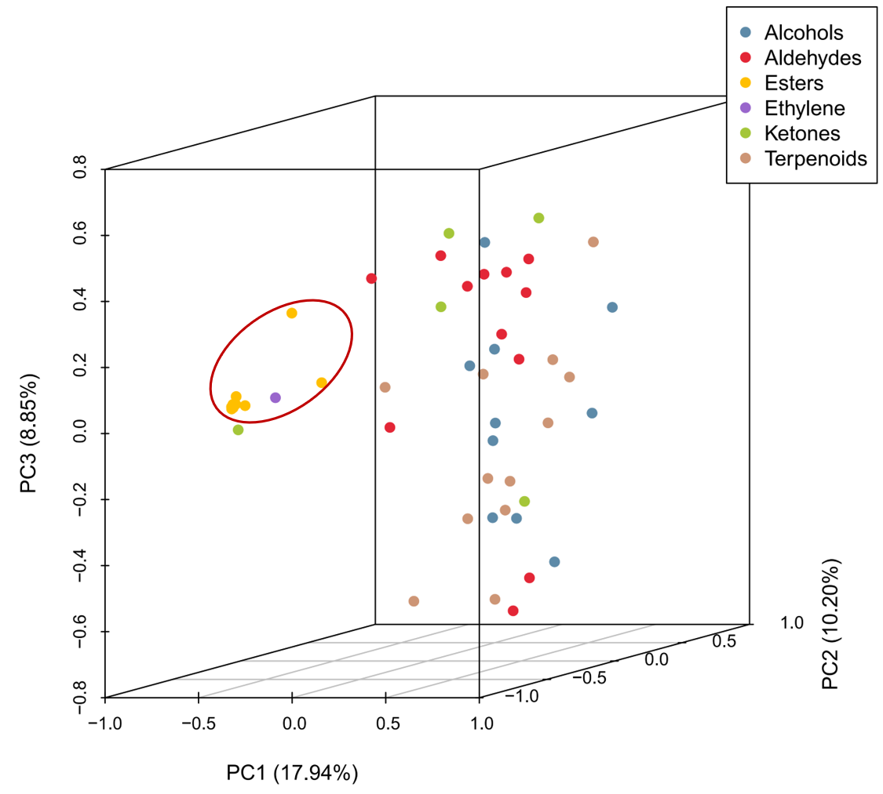
Additional file 2 Fig. S2 PCA analysis of the volitial compounds and ethylene production in kiwifruit treated with control, ethylene (100 µl l⁻¹, 24 h) and 1-MCP (1 µl l⁻¹, 24 h). The PCA analysis used mean data.

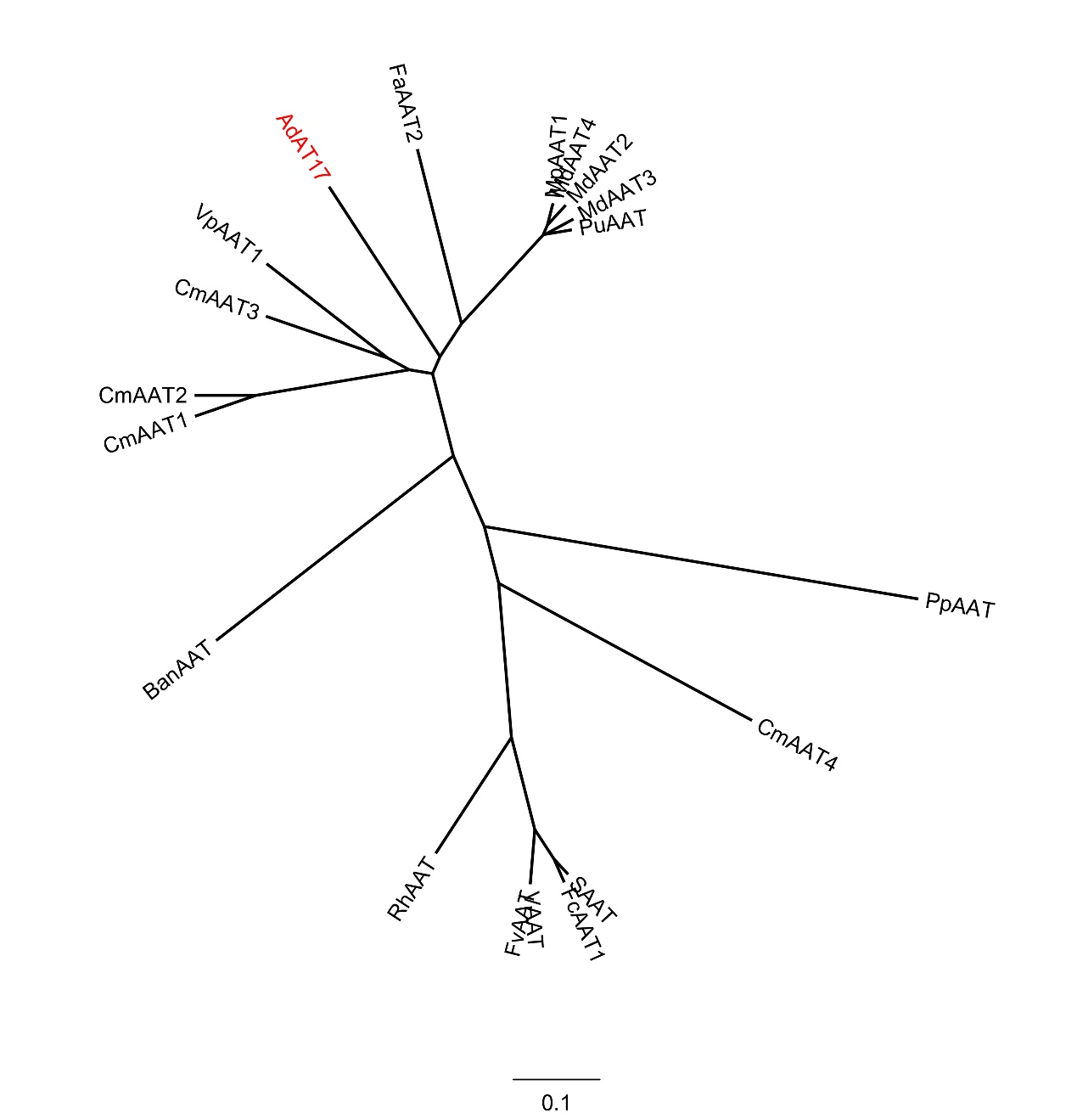
Additional file 2 Fig. S3. Phylogenetic tree analysis of kiwifruit AdAT17 and AAT sequences in other species. MpAAT1 (Malus pumila, AY707098), MdAAT2 (Malus domestica, AY517491), MdAAT3 (Malus domestica, AY512893), MdAAT4 (Malus domestica, AX025508), PuAAT (Pyrus communis, AY534530), BanAAT (Musa acuminata, AX025506), CmAAT1-4 (Cucumis melo, CAA94432, AAL77060, AAW51125, AAW51126), VpAAT1 (Vasconcellea pubescens, FJ548611), SAAT (Fragaria × ananassa, AAG13130), VAAT (Fragaria vesca, AX025504), FcAAT1 (Fragaria Chiloensis, FJ548610) FaAAT2 (Fragaria × ananassa, JN089766), FvAAT (Fragaria vesca, AAN07090), RhAAT (Rosa × hybrida, AAW31948), PpAAT (Prunus persica, XM_020562516.1). The phylogenetic trees were constructed using FigTree (v1.4.2).

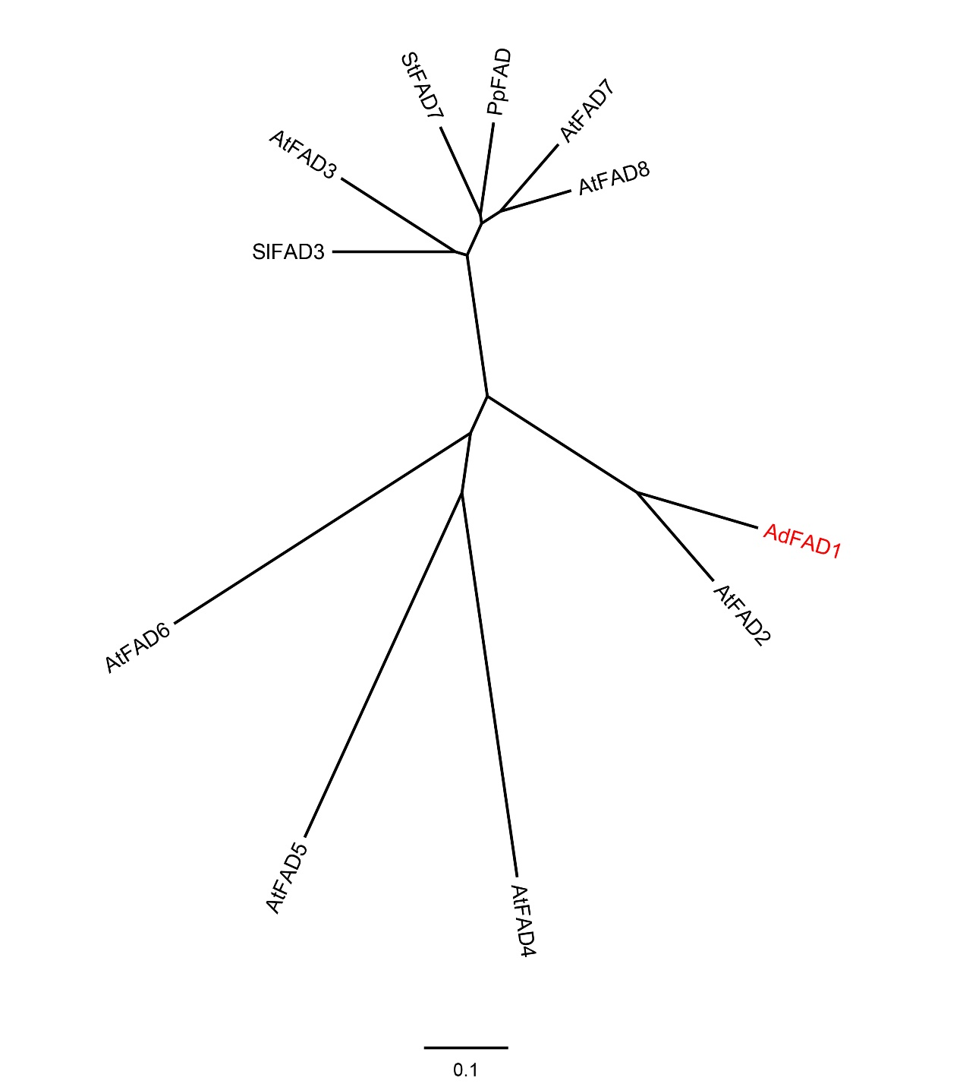

Additional file 2 Fig. S4. Phylogenetic tree analysis of kiwifruit AdFAD1 with Arabidopsis thaliana AtFAD2-8, tomato SlFAD3 (Solanum lycopersicum, EU251190.1) and StFAD7 (Solanum tuberosum, AJ007739.1). PpFAD (Prunus persica, XM_007217933.2). The deduced amino acid sequences of Arabidopsis thaliana FADs were obtained from TAIR. The phylogenetic trees were constructed using FigTree (v1.4.2).

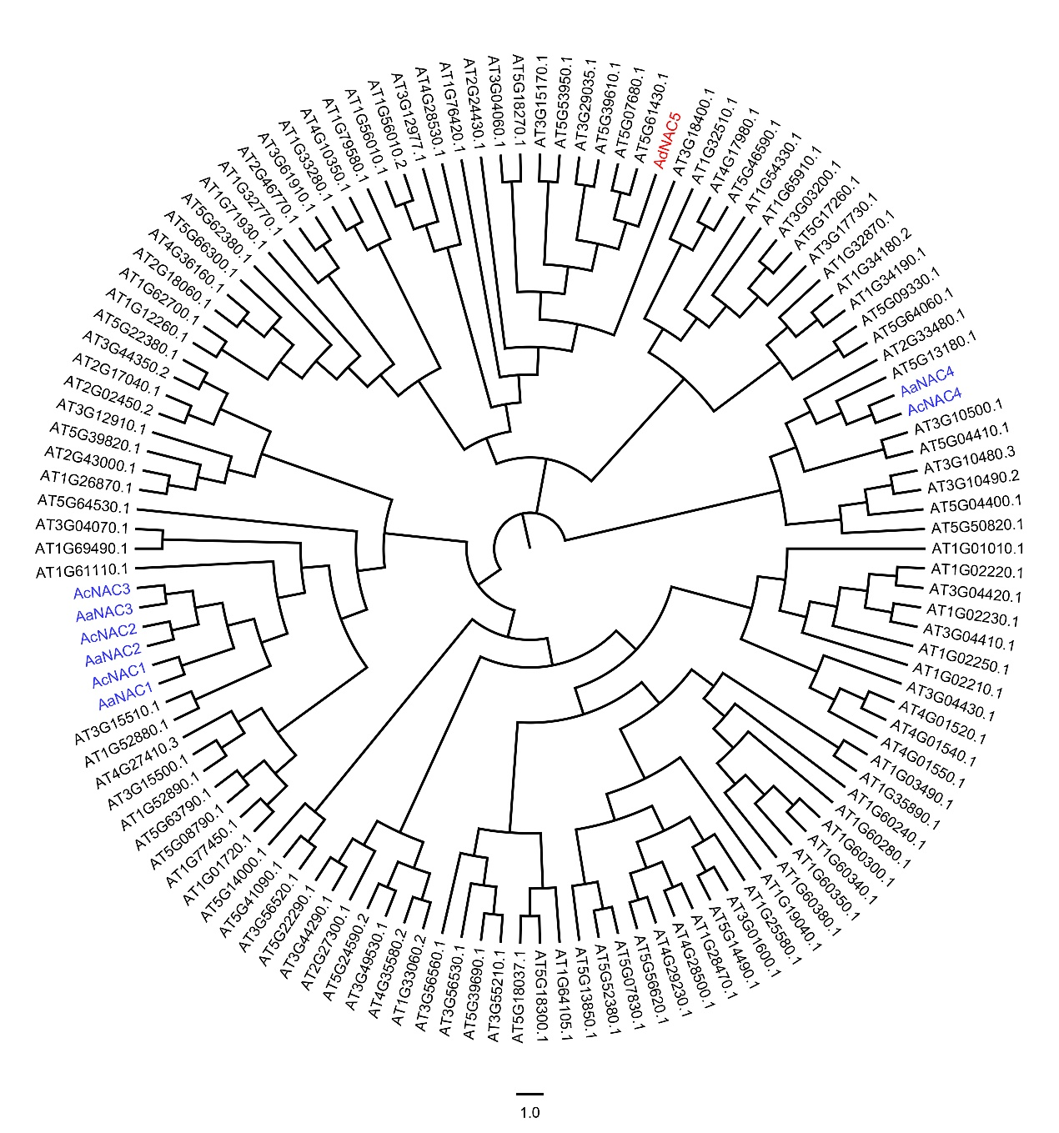

Additional file 2 Fig. S5. Phylogenetic tree analysis of AdNAC5 with kiwifruit (A. chinensis and A. arguta) reported NACs (AaNAC1, KF319046; AaNAC2, KF319047; AaNAC3, KF319048; AaNAC4, KF319049; AcNAC1, KF319050; AcNAC2, KF319051; AcNAC3, KF319052; AcNAC4, KF319053) and Arabidopsis thaliana. The deduced amino acid sequences of Arabidopsis thaliana NACs were obtained from TAIR.The phylogenetic trees were constructed using FigTree (v1.4.2).

